**SYS 611-TERM PROJECT**

**Model A Sport LEGO Vehicles Production**

**Advisor**

Prof. Paul Grogan

**Students**

Rushabh Barbhaya, Alkim Avsar

**Date**

December 17, 2018

1. **INTRODUCTION & MOTIVATION**
2. **OBJECTIVES**

In a production company, there are several aspects effecting your sales and profit. Manufacturing part is the one of the most essential parts since the production duration, quality and quantity of the product, labor cost and machine cost variables are all dependent to this part of the company. For a high profitable company, the managers are expecting to have the high efficiency rates from the manufacturing part. Task divisions in manufacturing processes can lead to a more efficient cycle. A manufacturing system having members specialized in smaller tasks rather than each person dealing with the larger task; increase its productivity and at the same time decrease the duration of production. Having a team member trained and specialized in just one task, makes that person quicker in that certain task. When you consider in this perception, having decreased production durations in each small task is going to give you a much efficient system level process. Moreover, controlling the workers and each small task would become much easier.

Accordingly, in this report we want to observe the efficiency differences between teams having specialized members in small tasks and teams having each member working on the large-scale task. We are going to use Model A Sport LEGO Vehicles Production in class activity data and create our own model for running simulations for different compositions of teams in order to observe the differences among teams.

1. **SYSTEM DESCRIPTION**

So, what is Model A Sport LEGO Vehicle Production Activity?

The aim of this activity is to observe differences between manufacture efficiencies in a limited time for mass production. For this purpose, there were three teams in the class activity having the same number of team members. The teams are supposed to buy their chassis and start producing their own cars and sell them to the buyers. They need to pass the quality check in order to be able to sell the cars to buyers. The team having the highest profit in the end of the activity becomes the winner. So the main goal is to build as many cars as possible in the limited time range.

The teams are supposed to build their cars from the LEGO parts provided by the designer of the activity. After that, they are free to create their own manufacturing model. There are 13 LEGO parts for being able to build the Model A Sport LEGO Vehicle:

1. Chassis (1 per car)
2. Side Section (2 per car)
3. Wheels (4 per car)
4. Wheel Trolley (2 per car)
5. Rear Lights (2 per car)
6. Back Section 1 (1 per car)
7. Back Section 2 (2 per car)
8. Single Seat (1 per car)
9. Steering Wheel (1 per car)
10. Front Section 1 (1 per car)
11. Front Section 2 (2 per car)
12. Front Section 3 (1 per car)
13. Headlights (2 per car)

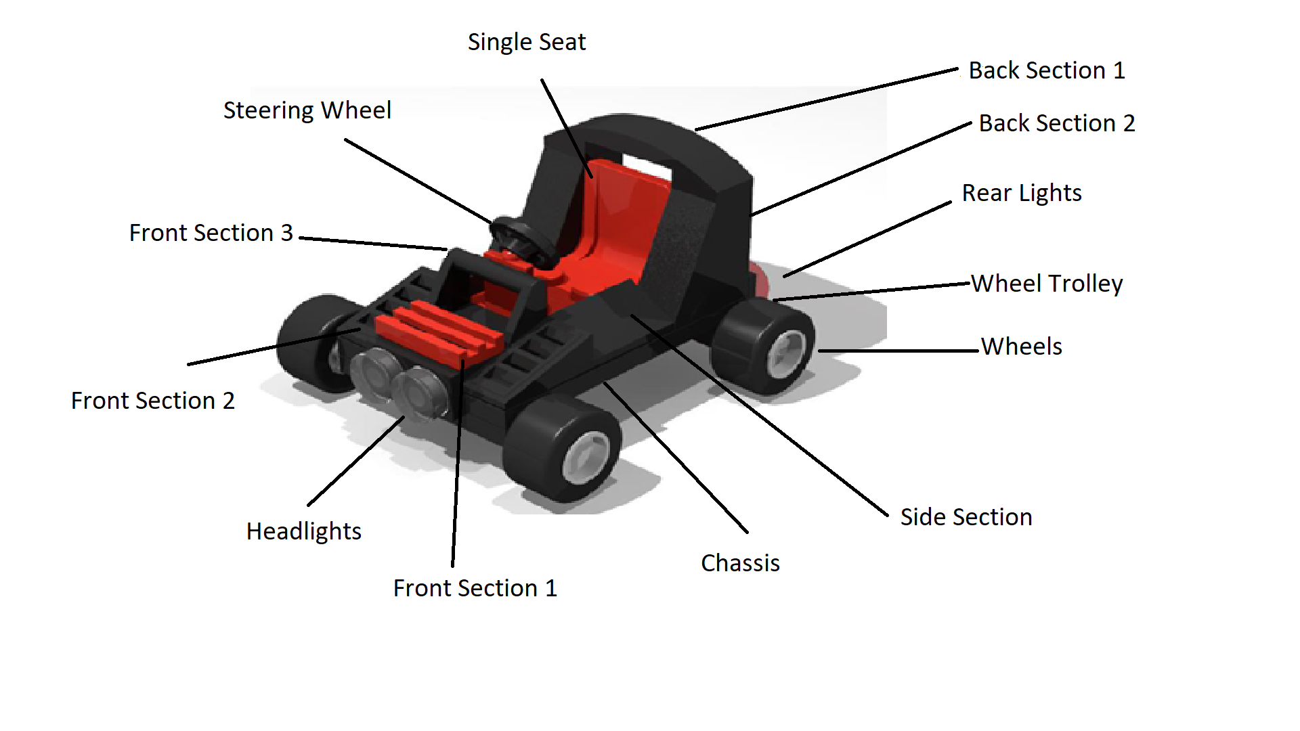

Image 1: Indicates the LEGO

1. **PERFORMANCE MEASURES**
2. **MODELING APPROACH**
3. **DATA COLLECTION AND PROCESSING**
4. **MODEL FORMULATION AND DEVELOPMENT**
5. **MODEL VALIDATION**
6. **RESULTS & ANALYSIS**
7. **DISCUSSION & CONCLUSION**
8. **REFERENCES**
9. <https://smallbusiness.chron.com/specialization-labor-can-lead-increased-productivity-12347.html>
10. <http://www.npd-solutions.com/pdt.html>